Example of Decision Tree Classifier

In this example we shall be implementing the Decision tree classification model to predict survival rates upon the world famous and easily accessible Titanic data set. We shall only be employing the pandas data frame and the sklearn split_train_test and tree function to test the model. Therefore, the pandas library is initially imported and the Titanic data set uploaded, as shown in Figure 1.

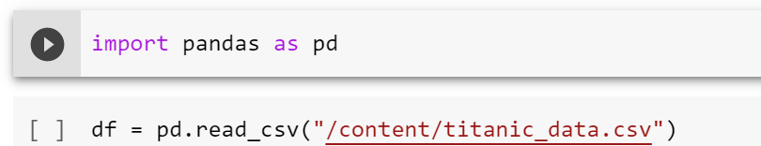
Figure 1: Relevant library is imported as well as the data set used for this model in Google Colab by Arden University.

As with any data study, it is always advantageous to initially view the data set in which the analysis / model is to be performed on. It is important to note that the model in which we want to predict is survival rates, therefore the survival rates of passengers onboard the ship would be out targeted (y) variable. Also, as part of the pre-processing stage, there could possibly be many features within the data set that would have no benefit to include, in other words they would not have a positive effect on the overall results. If this is the case this case, we would remove these features, as Figure 2 demonstrates below.

Figure 2: Displaying the data set and dropping irrelevant features in Google Colab by Arden University.

As can been seen from Figure 2, there are features included within the data set that would be irrelevant to include in our model. For example, we are initially assuming that the name of the passenger would hold no relevance to whether the person survived or not, which is why it has been removed. The other features detailed in Figure 2 have also been removed on this initial assumption. Having now engaged in some pre-processing and removed the assumed features, we can display the resulting data set, shown below.

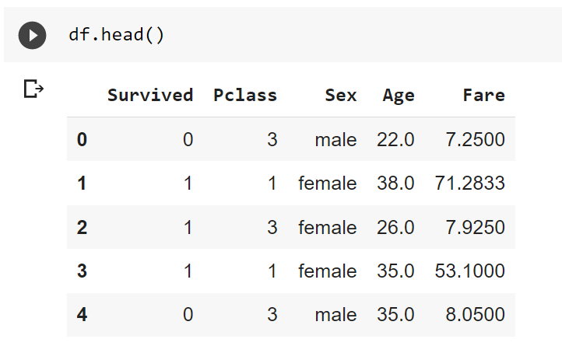
Figure 3: Pre-processed data set based upon initial assumptions in Google Colab by Arden University.

The resulting data set seen in Figure 3 is now more relevant to the intended outcome of the model, i.e. survived. The Fare feature has been included as this may give some interesting results in determining whether the person that survived, or not, was in first class. It is interesting also to know whether the person who survived was male or female. However, as was stated earlier on, these are initial assumptions on which features to include, the result and accuracy of the model will help us to determine whether these features were correctly assumed, or whether additional features need to be included, to improve the models accuracy.
At this stage we can set our targeted y feature as Survived and alter the Sex of a person, to convert the data into numerical data, shown in Figure 4.
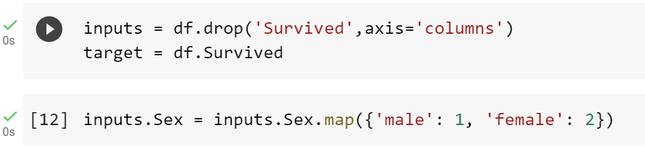
Figure 4: Creating the targeted variable and changing the Sex feature to numerical values in Google Colab by Arden University.
.
As the final part of the pre-processing stage, it is always advantageous to check the data set for missing values. It is assumed that as this particular data set has been freely available for some time, there will be no missing data values. However, it is always worth checking, as missing data will have a negative effect on the model and results. For this example, we shall only be checking the first 10 rows of the Age feature for missing values, but in a real-world application, you would check the entire data set.

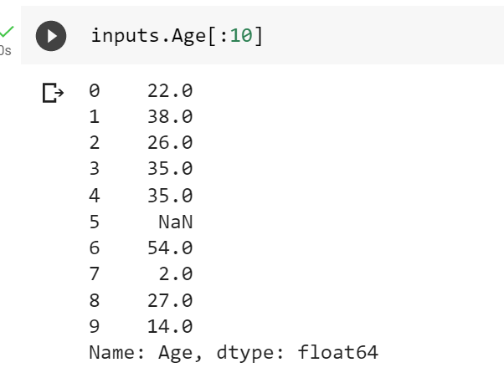
Figure 5: Checking for missing data in Google Colab by Arden University.

As can been seen from Figure 5, we have one missing data point. Therefore, we need to impute this in the most unbiased way possible. To do this, we use the mean of the entire Age feature and display the results to hopefully see the missing value being inserted, all shown below in Figure 6.
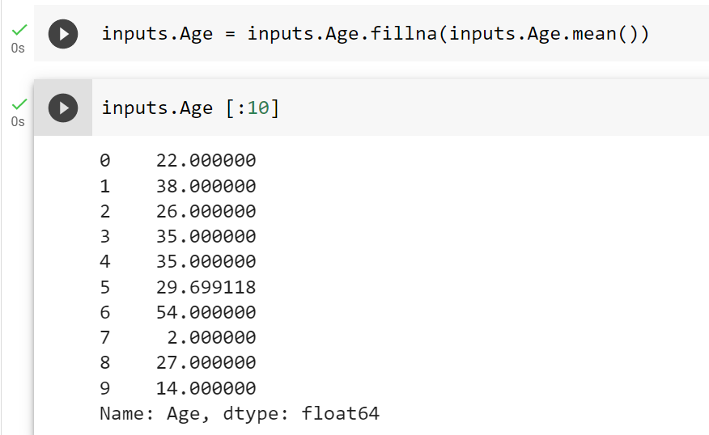
Figure 6: Performing imputation on the Age feature in an unbiased manner in Google Colab by Arden University.

The imputation has been successful and the missing data point has now been resolved. The pre-processing now complete, we can begin to build the Decision Tree classification model, by importing an additional library from sklearn and setting the train and test data to a 70/30 split on the training set. This means that 70% of the data set will be assigned as training data and 30% will be assigned as test data, to assess model accuracy. The creation and split of the data is shown in Figure 7.

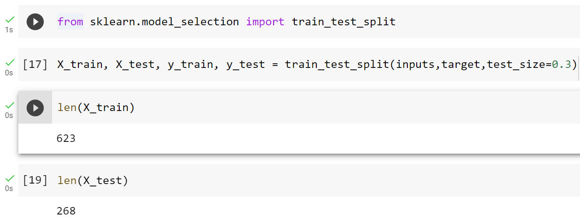
Figure 7: Importing the relevant library, splitting the data into train and test in Google Colab by Arden University.

The data now split and the associated data points allocated, we can define the Decision Tree classification model and fit it onto out training set. The construction and results are shown within Figure 8.

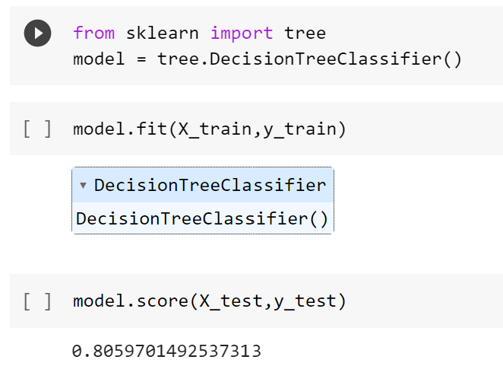

Figure 8: Model fitting and prediction accuracy in Google Colab by Arden University.

As can be clearly seen from Figure 8, the model has a prediction accuracy of 81% when rounded. This is good, as we used initial assumptions. However, as we would ideally want the accuracy of the model to be higher that 95% we would at this point go back to the data set and possible include additional features to increase, if possible, the accuracy of our model.

